URL: https://adityabirlahospital.com/doctors/dentist-in-pune
Home / Doctors / Dental
Best Dentists in Pimpri-Chinchwad, Pune
Dental health is a cornerstone of overall well-being, and at our hospital, we ensure that you receive exceptional care from experienced dental professionals. Our team of dentists in Pimpri Chinchwad, Pune specializes in everything from routine check-ups to advanced dental procedures, all delivered in a state-of-the-art environment.
Our Team of the Top Dentists in Pune
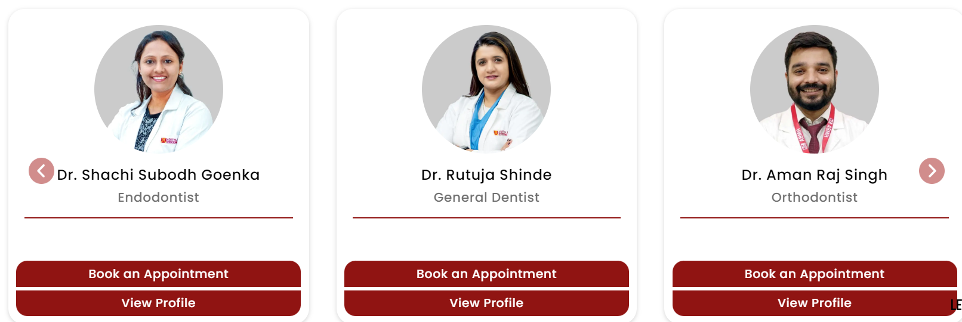
DR. SHRENIK OSWAL | BDS, MDS (Orthodontics & Dentofacial Orthopaedics) | Orthodontist
DR. PRAJAKTA SANAP | BDS, MDS (Conservative Dentistry & Endodontics) | Endodontist
DR. NIKHIL DAYAMA | BDS, MDS (Prosthodontics) | Prosthodontist
DR. ANUJA KAMBLE | BDS, MDS (Pedodontics) | Pedodontist
DR. MAYURI KALE | BDS, MDS (Pedodontics) | Pedodontist
DR. SUHAS PANDE | BDS, MDS (Oral Medicine & Radiology) | Oral Radiologist
DR. TUSHAR KOLHE | BDS, MDS (Orthodontics & Dentofacial Orthopaedics) | Orthodontist
DR. SHACHI GOENKA | BDS, MDS (Endodontics) | Endodontist
DR. RASHMI SAPKAL | BDS, MDS (Oral Medicine & Radiology) | Oral Medicine & Radiologist

Our hospital is home to some of the best dentists in Pimpri,Pune, offering a comprehensive range of dental services tailored to meet your unique needs. Whether you’re looking for preventive care, cosmetic dentistry, or advanced dental treatments, our experts provide personalized solutions with a focus on your comfort and health.
What Our Dentists Specialise In:
- Routine dental check-ups and preventive care
- Tooth-colored fillings, root canals, crowns, and bridges
- Dental implants and full mouth rehabilitation
- Teeth whitening and cosmetic smile design
- Orthodontic treatment with braces and clear aligners
- Pediatric dental care in a child-friendly setting
- Wisdom tooth extraction and minor oral surgeries
- Gum disease treatment and periodontal care
- Diagnosis and management of oral ulcers, precancerous lesions, and jaw disorders
- Advanced dental imaging (OPG, CBCT) for accurate diagnosis
- Temporomandibular joint (TMJ) disorder management
- Emergency dental care for trauma and pain relief
How to Find the Top Dentists Near Me in Pune?
If you’re searching for top dentists in PCMC, our dental hospital in Pimpri Pune is your trusted destination for expert dental care. We understand how important it is to find the right dentist, and our team is dedicated to providing a stress-free, high-quality experience every time.
Visit our hospital to access one of the most trusted dental teams in Pune, where your smile is our priority. Book your consultation today and take the first step toward achieving optimal dental health.
Nearby Locations:
Hinjewadi, Wakad, Baner, Aundh, Pimple Saudagar, Bhosari, Ravet, Chinchwad Gaon, Tathawade and Nigdi, PCMC, Pimpri, Moshi, and Chakan
